- Introduction
1.1 Nature of the Problem
In order to determine if the project will be successful, students are required to analyse the overall problem and present an initial design and project plan for solving it. The purpose of the initial report will assist students in their decision making and suggest possible recommendations on the development of this project. By analysing the nature of the problem, designing the project plan and identifying potential difficulties and suggesting possible strategies to overcome these issues students are able to determine the feasibility of this project.
The main objective of this project is to assemble the buggy robot and design a program that will navigate the robot through a fixed maze. In addition, the robot must also be programmed to play a tune which can be played during or after completing the maze. The project will consists of 5 to 6 students working together as a team in which certain tasks are equally allocated to each member of the team which in effect will all contribute to the final development of the project.
1.2 Resources
Each team will be provided with a file box which includes a PIC Buggy Self-Assembly Kit robot and the necessary tools required in accomplishing their project. This includes:
- Pack of PIC Buggy parts;
- Download cable;
- 4 AA batteries;
- Pliers;
- Wire cutter;
- Cross-head screwdriver;
- Buggy manual.
Therefore students should be able to successfully complete their project using only the materials in one robot kit. However, students are allowed to spend a maximum of $10 of their own money per team member on additional equipment.
Moreover, each group will be given a number of example code and students are required to familiarise themselves with the buggy robot, basic language and the programming editor. The example code includes the code for programming obstacle avoidance, movement to music and moving forward by following a wall. There are two types of mazes that the group will need to program and experiment with by creating their own maze. The first maze is considered to be flexible in which the maze is made up of a board with 10 wooden blocks which students are able to trial and conduct tests. The second maze however is a fixed pattern maze which will be used for the final demonstration. See diagrams below.
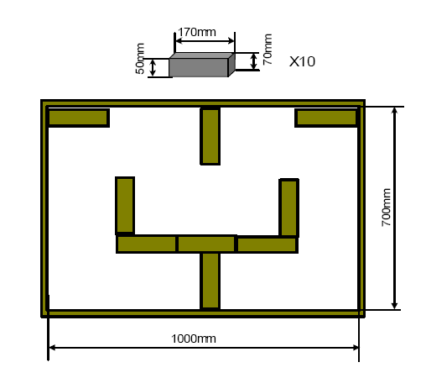

Schematic diagram of the flexible maze including a board and 10 wooden blocks
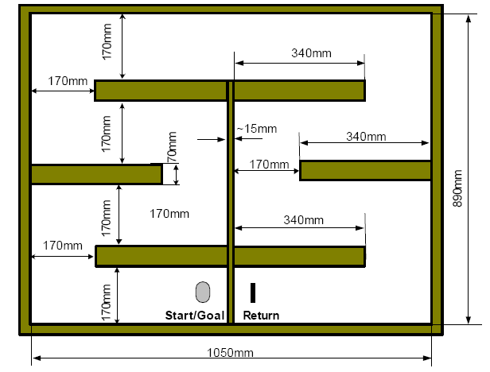

Schematic diagram of the fixed maze for demonstration/competition. The buggy robot starts from “Start/Goal” and reaches “ Return”, then travels back to “Start/Goal”.

(REFERENCE: ELEC1601 Foundations of Computer Systems Course Notebook, D C Levy p. 256)
- Project Plan
The time frame of this project will run throughout the entire semester in which an initial report, a detailed design report, a demonstration and assessment and finally a final report will need to be completed and submitted during certain weeks throughout the semester. In addition, time during uni will be allocated during the second hour of tutorials in which students are able to work only on their projects. Therefore an initial design and a breakdown of tasks must be enforced in order for the project to be successfully completed on time.
2.1 Initial Design
The initial design of this project will generally be based on the assembly instructions which can be found in the PIC Buggy Self-Assembly kit. See below.
Extra Assembly Instructions
1. Use a zero-ohm resistor to connect LK3 at the piezo sounder;
2. Use one of the soldering stations placed at the front of the Lab;
3. Use ribbon cables to connect the Micro switches to the PCB board so that the Micro switches can be flexibly mounted (refer to Figures 4 and 5);
4. To detect obstacles in front, mount the Micro switches as shown in Figure 4;
5. To follow a wall on the right hand side, mount the Micro switch B (right) as shown in Figure 5 so that the arm of the Micro switch can detect the wall.
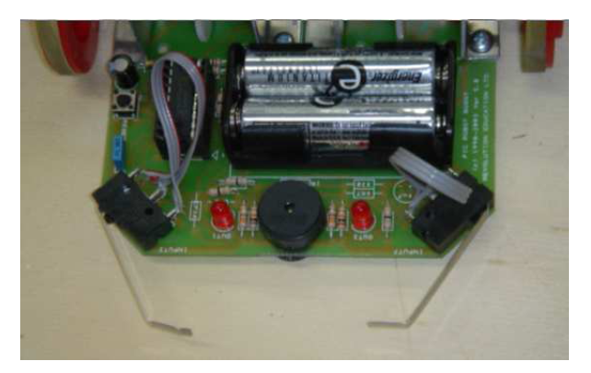
Figure 4: Micro switches are mounted in front to detect obstacles

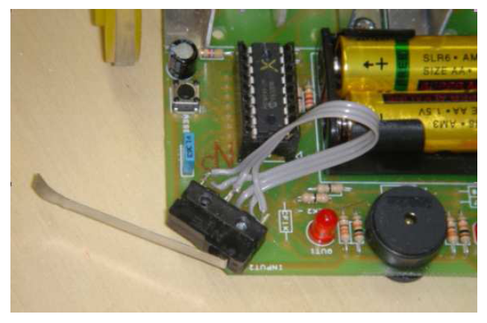
Figure 5: Right hand side Micro switch is mounted to enable its arm to detect a wall on the right hand side

(REFERENCE: ELEC1601 Foundations of Computer Systems Course Notebook, D C Levy p. 262-263)
2.2 Breakdown of Tasks
Task ID | Task Description | Duration (weeks)
A | Demonstration of working robot | 1 (week one)
B | Tutors providing guidance on managing the project | 2 (week two/three)
C | Organise into project teams  - Assemble PIC Buggy Self Assembly Kit  - Follow assembly instructions in the PIC Buggy manual | 1 (week four)
D | Soldering robot (there are 22 soldering points to complete) | 1(week five)
E | Complete final design with a component designed by each member  - Begin detailed design report due week 7: draft design, draft time schedule planned contribution of each member  - Detailed design: set out algorithms to be used for the robot to run the maze and play music, specify how it is planned for each member to contribute to completion and specify resources needed. | 1 (week six)
F | Complete detailed design report | 1 (week seven)
G | Programming the robot  - Download programming editor from the unit of study web page | 1 (week eight)
H | Testing the robot  - Observe and address any problems  - Suggest possible solutions | 1 (week nine)
I | Work on presentation  - Begin poster: explain solution (A3 in size)  - Assessment criteria: clarity and completeness of the presentation  - Testing: If robot successfully navigates through the maze from one end to the other, turn around and navigate back (continuous cycle), the buggy must play an audible and identifiable tune | 1 (week ten)
J | Complete and prepare presentation  - Testing  - Finalise presentation: organise the roles of each member in the presentation | 1 (week eleven)
K | Perform presentation and begin final report | 1 (week twelve)
L | Complete final report  - Reflect on own contribution  - Evaluate progress of the group  - Completed successfully in the time planned?  - Difficulties; anticipated or unexpected  - Solutions? How it can be done better? | 1 (week thirteen)

- Potential Difficulties and Possible Strategies
There will be a number of potential difficulties that may arise and will need to be address in order for the project to be successful. This will include addressing technical and administrative issues. Therefore students are required to evaluate possible strategies in overcoming these difficulties whether these issues are anticipated or unexpected and provide a suitable solution for each issue.
How to compensate for batteries that are not fully charged?
As stated in the resources, each team will be provided with a set of four AA Alkaline batteries. However from previous years and through research findings, it is clear that the speed of the buggy robot will depend on the voltage levels of the batteries. Therefore when the voltage changes the parameters of the program may need to be changed accordingly which in effect cause delay time. To avoid low voltage levels, the team must ensure that they buy extra batteries especially for the final demonstration. Before the final demonstration, the team should have a final trial and test if the buggy is running smoothly with its current batteries. If the team observes that the buggy could be running much faster than at its normal state, then a set of new batteries should replace the old batteries before the final demonstration to ensure that the buggy runs at its full potential.
What to do if the buggy robot gets stuck especially in a corner?
In this situation if the buggy robot does find itself stuck and is unable to find a direction to be unstuck, the team will be given the option to pick the robot up and place it back down to its preferred path. However the markers will deduct half a mark each time the robot is picked up. Therefore the team must ensure that the buggy robot is programmed accordingly in that the robot will be able to recognise that it is stuck and find a solution to this problem.
What to do if the buggy fails to operate?
If the buggy fails to operate, the team should check if all solder joints are well soldered, and that there are no accidental solder bridges. Also the team should also observe and check if all polarised components, including the two chips, are correctly inserted into the buggy and that the batteries are correctly inserted and are fully charged. Finally, the team should also check if the PIC16F627 is programmed correctly.

What to do if the buggy moves incorrectly, or veers to one side?
Similarly to the above issue, the team must first check the following as stated above especially the solder joints being correctly soldered on and that there are no accidental solder bridges. Once this has been checked, the team must now check if the red dots on the rear of the two motors are both facing inwards and check if the gearboxes rotate freely and are both square on the buggy. Finally, check if the worm gear is correctly located on the motor shaft and that the wheels are square and equal distance from the buggy on each side.

What to do if there is a free loader in the team?
As it as a team project, all group members are required to contribute a relatively equal amount of work. This means that if a member is assigned a task by the team, it is expected that they are able to complete this task at their full potential and is completed at the desired time. Therefore, to avoid this situation the team must understand what certain roles they play and what is required of them in completing the project.

